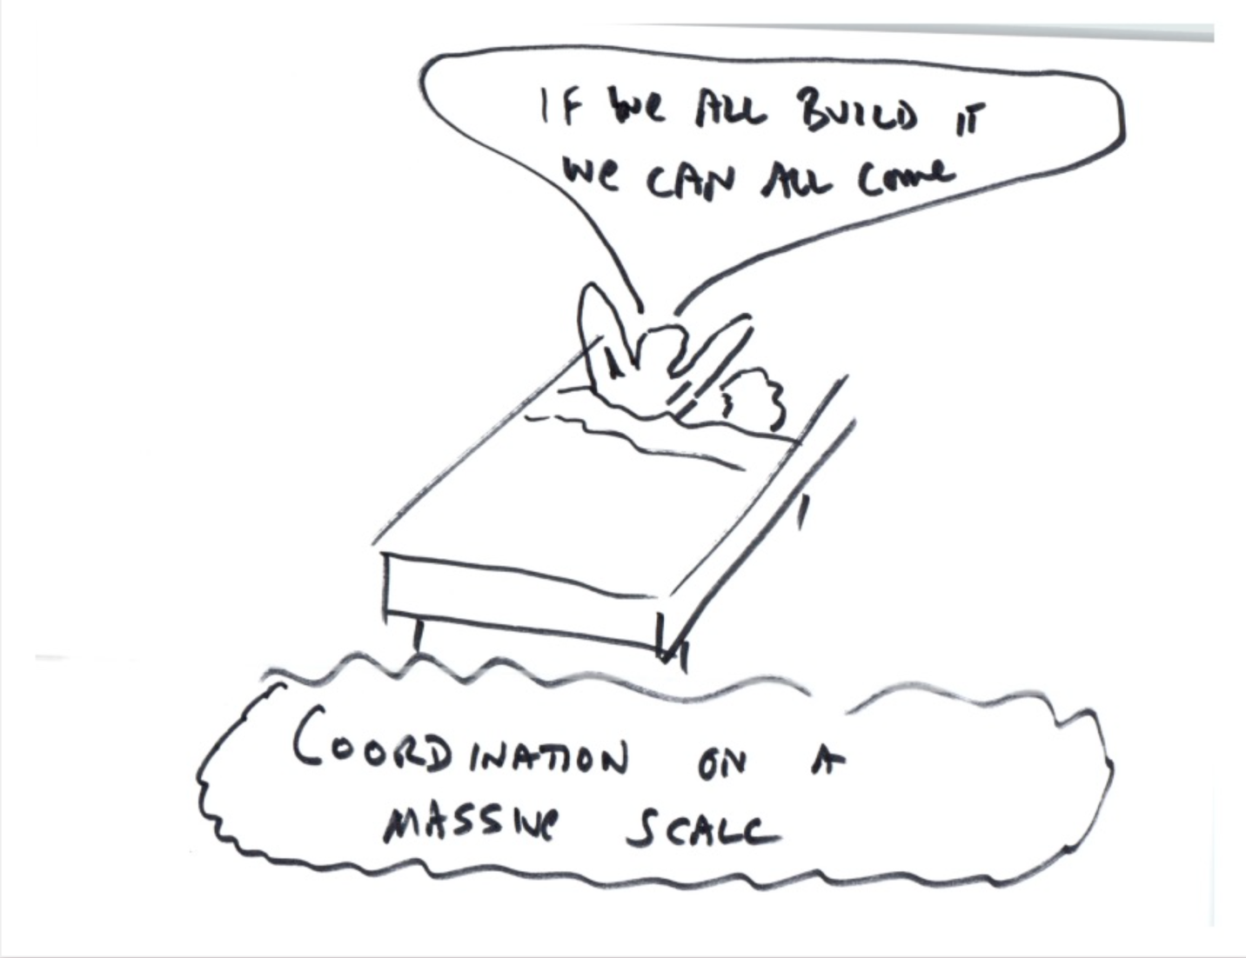

A long time ago people used to talk about the idea that we could solve the Prisoner’s Dilemma by using smart contracts. People called this various things: “Wisdom of the Crowd”, “Distributed Organizations”, “Commons Building”, etc. But one of the things that stuck with me was “Coordination on a Massive Scale.”

This image plays off of the famous saying from the 1989 Kevin Kostner movie “Field of Dreams” (which by the way is an evocative name for the way people used to think about crypto.) In that movie, a voice kept telling Kevin Kostner “If you build it, they will come.”

So combining the two things: “If we all build it, we all can come.”

I’m referring to all of us working together on a massive scale to coordinate building a world-wide instantaneous database called Ethereum, coordination on a massive scale, but when I said “If we all build it, we all can come” the above image came to mind.

It’s too overtly sexual, but there’s the core of an idea here and it’s kind of funny.